Name: Click or tap here to enter text.
Class: Click or tap here to enter text.
Introduction
National Apprenticeship Week provides a fantastic opportunity to help students to think about their future careers and to raise awareness of the different options available after school, including apprenticeships. We have put together this useful Apprenticeship Activity Pack with 10 different apprenticeship activity ideas for your students from pages 4 - 19 of this pack. We hope you enjoy using this pack and look forward to you sharing your feedback with us.
The student pack has been designed so that it can be completed individually, or in groups and both in-classroom or remotely.
Please note that some tasks will require access to a computer and the internet.
 | Hello@amazingapprenticeships.com |  | @AmazingAppsUK |  | @AmazingAppsUK

____________________________________________________________________________
Contents: Activity Sheets
Motivational Monday
Activity sheet 1: 25 apprenticeships you might not know about… 4
Activity sheet 2: Match the apprentice to the job 5
Talking Tuesday
Activity sheet 3: Meet Shaan, an apprentice with AstraZeneca 6
Activity sheet 4: Hear from the Armed Forces about their apprenticeship schemes 8
Wisdom Wednesday
Activity sheet 5: Understanding apprenticeships 10
Activity sheet 6: Apprenticeship quiz – Which apprenticeship am I? 12
Thoughtful Thursday
Activity sheet 7: What apprenticeship could I do if I worked at … 14
Activity sheet 8: Linking school subjects to apprenticeships 15
Fantastic Friday
Activity sheet 9: Apprenticeship wordsearch 17
Activity sheet 10: World Skills UK competitions 18

Motivational Monday
Apprenticeships are amazing! With nearly 600 different apprenticeship standards available, covering thousands of job roles, there is a lot to discover! These Motivational Monday activities will help you to explore the wide range of apprenticeships and find out about some of the different job roles that they could lead to.
____________________________________________________________________________

Before we start, let’s take a look at what apprenticeships actually are …
Click on the image below, and watch the short film (2 minutes)

This film is available at: https://vimeo.com/358762043

For a more detailed overview of apprenticeships, you can also watch our 15 minute presentation here: https://vimeo.com/412215955

TASK 1: 25 apprenticeships you might not know about…
To complete this task, please follow the following steps:
- Click on the image below to watch the short film (5 minutes) showing 25 different apprentices from across England. If you are working on a printed copy of the pack, to view the film, visit: www.AmazingApprenticeships.com/NAW2021
- Listen to the description that the presenter reads out about each apprenticeship.
- Read the three questions below and use the space to make a note of your answers.
If you are completing this online, please click on the box and start typing.
Of the 25 apprenticeships covered, which apprenticeships surprised you the most? List them below…

How many of the 25 company names did you recognise? List all of the employers that you can remember below…

Which apprenticeships are you now interested in finding out more about? List them below…

TASK 2: Match the apprentice to the job
To complete this task, please follow the following steps:
- Take a look at the pictures below and see if you can match the apprentice to their job role.
- Use the spaces under each photograph to write in the correct apprenticeship job role from the word bank and match it to the picture. You can click on the box or write on the line.
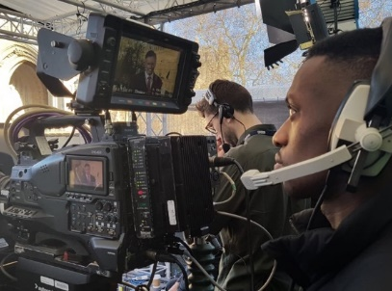
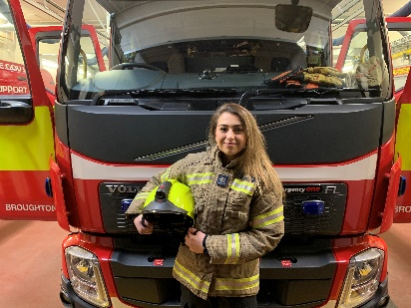

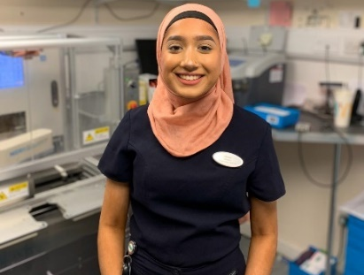
Click or tap here to enter text. Click or tap here to enter text. Click or tap here to enter text.
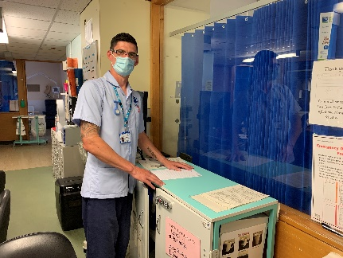
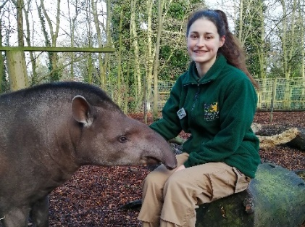
`

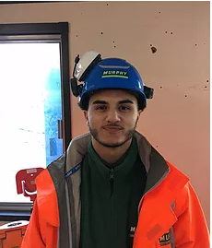
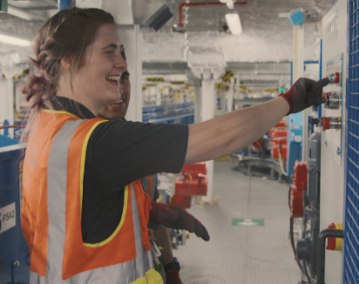
Click or tap here to enter text. Click or tap here to enter text. Click or tap here to enter text.

Click or tap here to enter text. Click or tap here to enter text. Click or tap here to enter text.
Word bank
Software Developer | Firefighter | Laboratory Technician
Media Broadcast Camera Operator | Zookeeper | Engineer
Hairdresser | Nurse | Project Manager
Talking Tuesday
Hear from apprentices and employers about their experiences of apprenticeships in the activities below.
____________________________________________________________________________
TASK 3: Meet Shaan, an apprentice with AstraZeneca
To complete this task, please follow the following steps:
- Use the words at the bottom of the page to fill in the blank spaces in the text.
- This will help you to learn more about Shaan’s apprenticeship.
- Remember, you can only use the words once, so complete the tick box as you go!

Hi, my name is Shaan Gill and I am currently completing a Level 6 degree apprenticeship with AstraZeneca and the University of Kent, which will take 4 years and 9 months to complete.
The end result will be a BSc Bioscience Click or tap here to enter text. and just under 5 years industry work experience. My time is split 20/80 between study and work, 1 day a week is dedicated to studying online via distance learning with the University of Kent and the remaining 4 days working at Click or tap here to enter text..

I am based in the Oncology Translational Medicine department. We carry out biomarker analysis of human tissue and blood samples from real patients enrolled in AstraZeneca clinical trials testing new cancer medicines. The data produced is used to:
- Understand the impact of the Click or tap here to enter text. on the tumour and microenvironment
- Define dosage levels and schedule
- Identify the right patient populations
- Define the mechanism of resistance
My typical day can be very varied as I tend to work across multiple projects.
If I am in an early stage of a project, I am more office based; doing Click or tap here to enter text., answering emails, having meetings with project leads and making plans or workflows. This is a very interesting part as I get to learn about the scientific rationale behind a project and the medicine.
In the middle of a project, I am heavily lab based. I am in the lab prepping or doing experiments. This is my favourite part of my job as I get to advance my skills, learn a new technique and do practical work.
Towards the end of a project, it is a mixture of office and lab. I am looking at my results, doing quality control and data analysis. If required I may need to repeat an Click or tap here to enter text., if samples failed, or to attempt to get better quality results. This part is great as the project comes together and I can see the bigger picture.
I get to see how the work I do and data I produce is beneficial to the project and what conclusions are made from it. Knowing the work I do benefits Click or tap here to enter text. makes every project incredibly rewarding to work on. I’m very appreciative of the opportunity knowing that I can make an impact and difference, even as an apprentice.
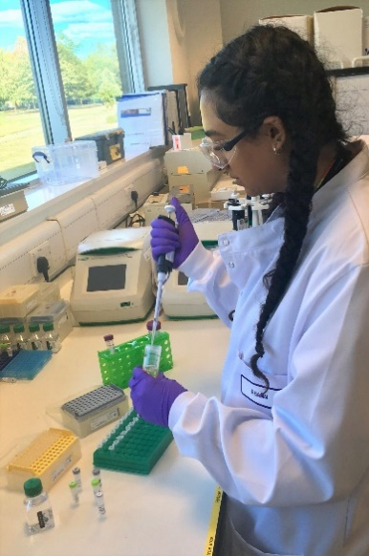
I discovered degree level apprenticeships during a half-term work experience week at GlaxoSmithKline when I was in sixth form.
As soon as I heard about it, it had more appeal to me over university as I was keen to get into the Click or tap here to enter text. as soon as possible. I researched more degree level apprenticeships in the science industry using the Gov.uk website.
Despite being keen for an apprenticeship I only applied to two; one at GlaxoSmithKline and one at AstraZeneca as both are large pharmaceutical companies with good Click or tap here to enter text. and within a good distance. Additionally, I still applied to university as the apprenticeships I applied for were Click or tap here to enter text. so I needed a backup and I wanted to have options.
At the time, I was still undecided which path was better for me and what I would enjoy more. I personally found it rather daunting to give up the conventional and safe route of university for an apprenticeship in which I had to juggle working as well as Click or tap here to enter text..
The interview process put me at ease once I saw where I would be working, who my potential colleagues would be, and understood more of what my role and course would entail. After the interview I was more set on an apprenticeship being the right path for me.
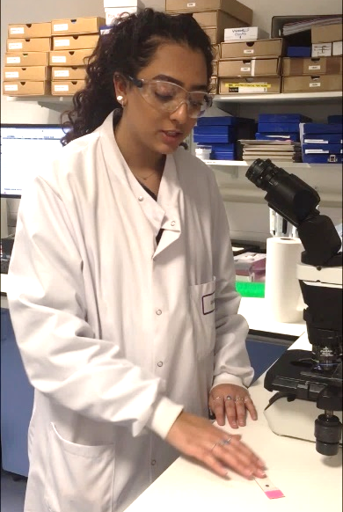
AstraZeneca has a very supportive and inclusive culture, providing a great environment to Click or tap here to enter text. my career. I am constantly supported in both my work and studies and provided with personal development opportunities.
Everyone is always willing to take time to answer questions, give advice and share their knowledge. I genuinely feel like everyone wants me to succeed and are always there to help me develop and encourage me to expand my skills.
Studying for a BSc degree whilst working for a world leading pharmaceutical company and contributing to real science is amazing, as well as earning a salary and being debt free!
I found numerous benefits from the apprenticeship programme. The most apparent advantage being the vast amount of hands-on Click or tap here to enter text. gained throughout the programme. At my apprenticeship, I’ve been able to work in a world leading pharmaceutical company contributing to real oncology drug development from the first day!
Word bank
Medicine | studying | degree | workplace
AstraZeneca | patients | reputations | experiment
kickstart | research | competitive | experience

TASK 4: Hear from the Armed Forces about their apprenticeship schemes
To complete this task, please follow the following steps:
- Click on the images below and watch each of the films for The Army, The Royal Navy and The Royal Air Force.
- If you are working on a printed copy of the pack, go to the URLs below each of the films to watch.
- Answer the questions below about the different apprenticeship schemes available.
If you are completing this online, please click on the box and start typing.
The Army | The Royal Air Force | The Royal Navy
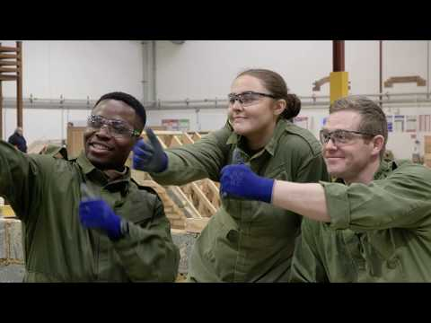 | 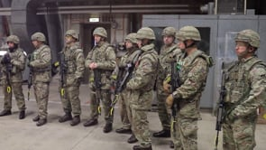
tinyurl.com/y47ndo4p | tinyurl.com/yxm7ny2d | tinyurl.com/y4mhqs2y

Q1.
In which of the films did they note ‘getting to travel’ and the ‘opportunity to do lots of sports’ as benefits of joining as an apprentice?
Choose an item.

Q2.
In the Army film, what task were the four apprentices completing together?
Click or tap here to enter text.

Q3.
In the Royal Air Force film, how old could you be to do the Chef apprenticeship?
Click or tap here to enter text.

Q4.
How long does Phase 1 training take in the Royal Air Force?
Click or tap here to enter text.

Q5.
What does the first apprentice in the Royal Navy film say is the main benefit of being an apprentice?
Click or tap here to enter text.

Q6.
How was the telecoms apprentice preparing for the exercise the following day in the Army film?
Click or tap here to enter text.

Q7.
What were the three example scenarios given of how an apprenticeship could vary day to day in the Royal Navy film?
Click or tap here to enter text.

Q8.
Do you have to have A Levels to get into a Royal Air Force apprenticeship?
Click or tap here to enter text.

Q9.
What was the first apprenticeship job role we heard in the Army film?
Click or tap here to enter text.

Q10. Bonus question
How many of the Armed Forces do you think were listed in the ‘Top 100 Apprenticeship Employers 2020’ listing by the National Apprenticeship Service?
☐ 1 ☐ 2 ☐ All 3 services

If you are interested in finding out more about apprenticeship opportunities with the Armed Forces, visit our dedicated page www.amazingapprenticeships.com/armed-forces where you can access a presentation and other interesting resources.

Wisdom Wednesday
Work through the next two activities to understand more about apprenticeships.
Wisdom Wednesday is all about building your knowledge of what apprenticeships are
and how they can benefit you.
____________________________________________________________________________

TASK 5: Understanding apprenticeships
Part 1: To complete this task, please follow the following steps:
- Click on the image below and watch the short film (4 minutes) to hear about apprenticeships from apprentices themselves.
- If you are working on a printed copy of the pack, go to https://vimeo.com/151121127
- Once you have watched video, read the statements below and tick whether you think they are true or false.

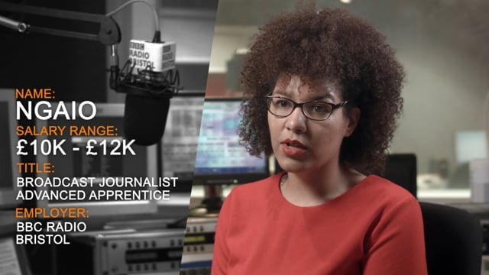
 |  | True | False
1. | Apprenticeships are a real job | ☐ | ☐
2. | Apprenticeships are a back-up option to college or University | ☐ | ☐
3. | There are opportunities to work your way up the organisation | ☐ | ☐
4. | Apprenticeships are low-skilled | ☐ | ☐
5. | Apprentices have real responsibilities within their job role | ☐ | ☐
6. | Studying for an apprenticeship is easy | ☐ | ☐
7. | Apprenticeships are low paid | ☐ | ☐
8. | Apprenticeships are only with small organisations | ☐ | ☐

Part 2: To complete this task, please follow the following steps:
- Go to https://www.bigassembly.org/ and catch up on yesterday’s Big Assembly 2021.
- Read the question below and use the space to make a note of your answers.
If you are completing this online, please click on the box and start typing.

What other myths about apprenticeships did they discuss during The Big Assembly? List them below…
Click or tap here to enter text.

Which of these surprised you? Make a list of these below…
Click or tap here to enter text.

Did any other facts about apprenticeships surprise you? List these below…
Click or tap here to enter text.

TASK 6: Apprenticeship quiz – Which apprenticeship am I?
To complete this task, please follow the following steps:
- Complete the quiz below to test out your knowledge of the range of apprenticeships available!
- The quiz is also available online: http://amazingapprenticeships.com/resource/which-apprenticeship-am-i-quiz
- Tick the box to indicate the correct answer.

Q1 | In this role, I …  - Interact with internal and external customers  - Help to manage and organise day to day tasks  - Must be able to use different IT skills and produce accurate business reports and documents | Answers  ☐ A. Chef  ☐ B. Business Administrator  ☐ C. Retailer
Q2 | In this role, I need to …  - Give support, care and advice during pregnancy  - Examine and monitor pregnant women  - Assess care requirements and write care plans | Answers  ☐ A. Midwife  ☐ B. Research Scientist  ☐ C. Dental Nurse
Q3 | In this role, I need to …  - Manage expenditure and income of projects  - Manage the selection of the specialist contractors for the project  - Have good communication with team and clients | Answers  ☐ A. Teacher  ☐ B. Quantity Surveyor  ☐ C. Civil Engineer
Q4 | In this role, I need to …  - Keep children healthy and safe  - Ensure that young children learn and develop  - Be professional and adapt to different ages | Answers  ☐ A. Early Years Educator  ☐ B. Youth Worker  ☐ C. Hairdresser
Q5 | In this role, I …  - Plan, lead and conduct experiments  - Analyse results and write reports  - Help to develop new products, processes or commercial applications | Answers  ☐ A. Optical Assistant  ☐ B. Research Scientist  ☐ C. Paramedic
Q6 | In this role, I …  - Help with the everyday care of animals, preparing feeds and cleaning their environments  - Observe and understand animal behaviour, recording and reporting findings  - Engage with visitors and stakeholders, tailoring information to the audience | Answers  ☐ A. Equine Groom  ☐ B. Keeper and Aquarist  ☐ C. Animal Trainer

Q7 | In this role, I …  - Help people who are affected by injury, ageing, illness or disability  - Provide movement, exercise and manual therapy to optimise an individual’s mobility  - Educate and promote good health and how to prevent injury | Answers  ☐ A. Community Activator Coach  ☐ B. Arts Therapist  ☐ C. Physiotherapist
Q8 | In this role, I need to …  - Direct aircraft and prevent collisions between aircraft / other obstacles  - Give clear instructions and have good communication skills  - Maintain radio contact with aircraft, issuing instructions and monitoring data | Answers  ☐ A. Air Traffic Controller  ☐ B. Cabin Crew  ☐ C. Marine Pilot
Q9 | In this role, I …  - Carry out quantity control and welding inspections  - Ensure the safety of nuclear sites  - Make detailed records and give technical feedback | Answers  ☐ A. Nuclear Scientist  ☐ B. Nuclear Welding Inspection  Technician  ☐ C. Engineering Design and  Draughtsperson
Q10 | In this role, I need to …  - Coach clients on a 1:1 basis or in a small group  - Help to improve people’s fitness and health goals  - Create personal plans for the clients | Answers  ☐ A. Bicycle Mechanic  ☐ B. Survival Equipment Fitter  ☐ C. Personal Trainer

All of the answer options included in this quiz are real apprenticeship jobs!

To find out more about the different types of apprenticeships available, please visit: www.apprenticeshipguide.co.uk
To search for current apprenticeship vacancies, go to: https://www.gov.uk/apply-apprenticeship

Thoughtful Thursday
Throughout the week you will have been building your knowledge and understanding about apprenticeships. Thoughtful Thursday is about taking some time to think about some of the less obvious apprenticeships that you could explore.
____________________________________________________________________________
TASK 7: What apprenticeship could I do if I worked at …
To complete this task, please follow the following steps:
- Look at the venues included in the box below.
- Set your timer to 5 minutes for each venue and try to write down as many different apprentice roles you can think of who may work, or have worked, at these venues.
Hints & tips
Try to think outside of the box. For example, could there be jobs connected to the stadium? Perhaps in the restaurants, as part of the security teams, in the events or maintenance teams, or working for the athletes.

Venues
Music venue Airport Stadium

Apprenticeship job roles I can think of …
Music venue | Airport | Stadium
Click or tap here to enter text. | Click or tap here to enter text. | Click or tap here to enter text.
TASK 8: Linking school subjects to apprenticeships
Part 1 - To complete this task, please follow the following steps:
- Click on the image below and watch the short film (2 minutes).
If you are working on a printed copy of the pack, go to https://vimeo.com/410197487
- Using the ideas shared in the video, now think about which skills you are developing through your favourite subject. Include these on the mind map below.
- If you think of more skills, add these into the spaces. If you are completing this online, you can add these into the same box you have already used.

Click or tap here to enter text.

Click or tap here to enter text.
Click or tap here to enter text.
Click or tap here to enter text.
My favourite subject:
Click or tap here to enter text.

Click or tap here to enter text.
Click or tap here to enter text.

Click or tap here to enter text. Click or tap here to enter text.
Part 2 - To complete this task, please follow the following steps:
- Once you have done this, go to www.amazingapprenticeships.com/NAW2021 and take a look at the ‘Subject Poster Bundle’.
- Read through the different apprenticeship opportunities linked to each subject.
- As you are looking at these, start to think about what skills those jobs might require.
- Add these to the mind map below and complete the tick box for the ones that interest you.
(The apprenticeships can be from any poster, they do not have to be from your favourite subject)

Click or tap here to enter text. ☐

Click or tap here to enter text. ☐
Click or tap here to enter text. ☐
Click or tap here to enter text. ☐
Apprenticeships linked to my skills

Click or tap here to enter text. ☐
Click or tap here to enter text. ☐

Click or tap here to enter text. ☐
Click or tap here to enter text. ☐

Fantastic Friday
Fantastic Friday is all about celebrating the amazing opportunities through apprenticeships! Take a look at some of the top employers offering apprenticeships, as well as the international skills competitions open to apprentices all across the world.
____________________________________________________________________________
TASK 9: Apprenticeship wordsearch
To complete this task, please follow the following steps:
- There are hundreds of fantastic employers who recruit apprentices.
- Look for the 15 employers listed below hidden in the wordsearch. Circle them once you find them.
- If you are completing this document online, you can play this wordsearch here: https://thewordsearch.com/puzzle/1831633/employer-wordsearch/
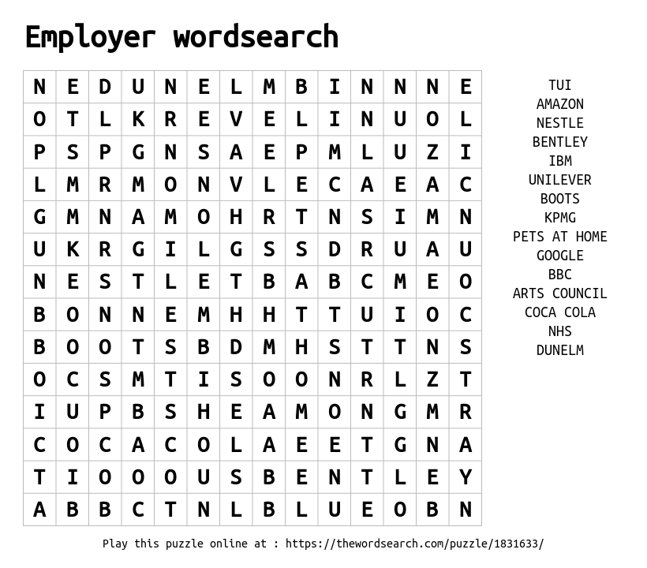
To find more top apprenticeship employers in England, visit: www.amazingapprenticeships.com/vacancies
TASK 10: World Skills UK competitions
Nothing celebrates the achievements of apprentices like the World Skills UK competitions.
Apprentices compete regionally, nationally and internationally for the title of Champion in their field.
Part 1 - To complete this task, please follow the following steps:
- Go to https://www.worldskillsuk.org/skills/how-competitions-work/ and read more about how the competitions work.
- Once you have finished reading, complete the table below with the missing information.
If you are completing this online, please click on the box and start typing.

Every two years an Click or tap here to enter text. competition is held between approximately Click or tap here to enter text. countries. Team UK will compete in up to Click or tap here to enter text. skill areas in the next international competition.
Every (alternate) two years a European competition is held (EuroSkills) between approximately Click or tap here to enter text. countries. Team UK will compete in up to 25 skill areas in the next EuroSkills.

Part 2 - To complete this task, please follow the following steps:
- Click on the image below to watch the video about the 2019 international competition in Russia.
If you are working on a printed copy of the pack, go to https://youtu.be/2n1GWf9jIWk
- Read the questions below and use the space to make a note of your answers.
- If you are completing this online, please click on the box and start typing.

What did you think about the World Skills competition?
Click or tap here to enter text.

What surprised you about the competition?
Click or tap here to enter text.

Part 3 - To complete this task, please follow the following steps:
- Go to https://www.worldskillsuk.org/skills/international-competition/worldskills-kazan-2019/
- Take a look at the participants and winners from Team UK in 2019’s Kazan team

Were there any job roles that you didn’t expect would compete?
Click or tap here to enter text.

Created by:

For more apprenticeship information and free resources, please visit:
www.amazingapprenticeships.com

Get in touch and let us know what you think of this resource:
hello@amazingapprenticeships.com

Find us on social media:
@AmazingAppsUK
@AmazingAppsUK

